**Demographic research**

* 23% of respondents 65 years old and older report playing games.
* Overall, men (55%) are slightly more likely than women (50%), and urbanites (56%) are a bit more likely than rural-dwellers (47%) to play any kind of digital game.
* Over one-third (36%) of gamers 65 and older say they play games everyday or almost everyday, compared with 19% of adults aged 50-64, 20% of adults aged 30-49, and 20% of adults aged 18-29. Senior gamers may play more frequently because they have more time to play than younger gamers, as 77% of senior gamers reported being retired.

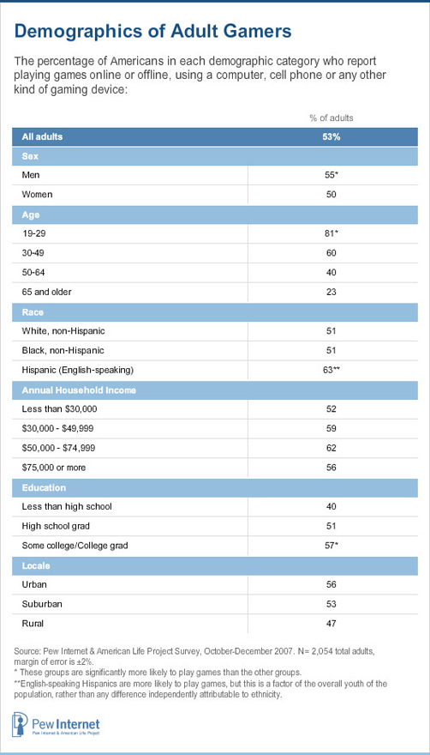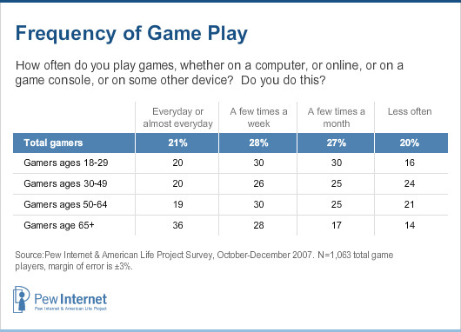

* 18% who play on a cell phone

Source : http://www.pewinternet.org/2008/12/07/adults-and-video-games/